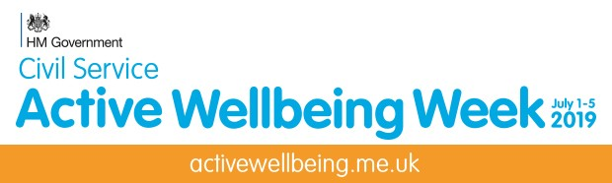

It’s time to make your move with CSSC!
The 2019 Active Wellbeing Week is happening once again from 1-5 July. Following the success of last year we are now giving you the opportunity to once again encourage the civil service and public sector employees to lead healthier, more active lifestyles.
There'll be loads to look forward to during the week, including a nationwide ‘make a pledge’ campaign, where you can make a personal pledge on how you intend to be more active. There are loads of prizes to win, including holiday vouchers worth £2,500. Lots more prizes will be announced along the way!
Get involved
There are a few ways that you can get involved and get inspired about leading more active, healthier lives through the Active Wellbeing Week.
- Make a pledge about how you intend to get more active
- Request our free physical workplace packs, ready decorate your offices and spread the word
- Organise a workplace activity for you and your colleagues, funded and supported by CSSC!
- Download posters and other support material to help drum up support
- Share your involvement in Active Wellbeing Week on social media, using the hashtag #ActiveWellbeingWeek
For full details and to make a pledge, visit activewellbeing.me.uk.
Active Wellbeing Week is being delivered by CSSC Sports & Leisure and CS Employee Policy (CSEP), designed specifically for employees in the civil service, with the aim of affecting change in the lives of thousands, by encouraging a healthier, more active lifestyle.
For more information on CSSC or to join, visit cssc.co.uk

