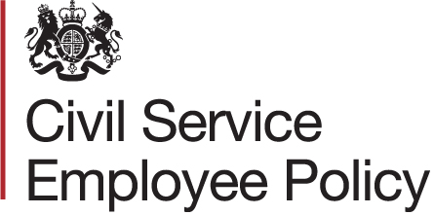

Intranet messaging for departments

For the run up to Civil Service Active Wellbeing Week 2018
Last year some of you may have supported Physical Activity Week and experienced at first hand the benefits to your overall wellbeing.
Civil Service Physical Activity Week was launched in July 2016 to encourage civil servants to move more during the working day. This year, we have partnered with Civil Service Sports Council (CSSC), rebranding the campaign as Civil Service Active Wellbeing Week, to offer a broader range of events and activities.
In 2017, the Civil Service Health and Wellbeing Champion, Jonathan Jones, launched five strategic priorities. One of these is to advocate the benefits of a healthy lifestyle, which promotes and encourages being active. Activity is about more than taking part in sports or going to the gym, but can also include general activity as part of a family outing, swimming, or dancing to your favourite music – any type of movement that you enjoy.
NHS guidelines advise adults to do a minimum of 150 minutes of moderately intense aerobic activity, or 75 minutes of vigorous activity every week. This can help prevent the onset of some illnesses like type 2 diabetes, Musculoskeletal Disorders (MSDs) and heart disease. Being physically active can also elevate your mood and levels of concentration and energy.
CSSC has produced a dedicated website for Civil Service Active Wellbeing Week 2018, where you can pledge to be more active. If you sign up to make a pledge, you will automatically be entered into a daily prize draw. You will also find details of other CSSC offers available to members and non-members during the campaign. Why not make a pledge today, and improve your wellbeing.
[DN: departments to add details of planned activities]

For the start of the 2018 Civil Service Active Wellbeing Week

As Civil Service Active Wellbeing Week 2018 gets underway, consider making a pledge to increase your activity levels, or even try a new activity. You may find something new on the CS Active Wellbeing Week website. Just a few small changes could make all the difference to your wellbeing.
We spend more time in sedentary roles than ever before, with long commutes and sitting behind a desk all day. The Department of Health has dubbed inactivity as the ‘silent killer’, being harmful to our health and wellbeing. Following the NHS guidelines of 150 minutes of moderate exercise a week can have a huge impact on health, helping to prevent illnesses like heart disease and Musculoskeletal disorders. Taking part in some activity for just 30 minutes a day can also improve your mood and increase energy levels.
The Civil Service Active Wellbeing Week website has lots of information to help make some small changes to your activity levels. Why not make a pledge to be more active and have the chance to win one of the prizes on offer in the free prize draw? The Chair of CSSC, Philip Rycroft has blogged this week, please have a read for more information [insert link to blog].

