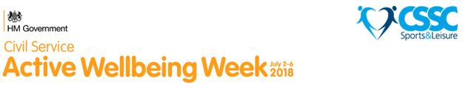

It’s time to make your move with CSSC!
The 2018 Active Wellbeing Week is happening from 2-6 July and has been created to encourage civil service and public sector employees to lead healthier, more active lifestyles.
There'll be loads to look forward to during the week, including a nationwide ‘make a pledge’ campaign, where you can make a personal pledge on how you intend to be more active. There are even prizes to win.
Get involved
There are a few ways that you can get involved and get inspired about leading more active, healthier lives through the Active Wellbeing Week.
- Make a pledge about how you intend to get more active
- Download posters and other support material to help drum up support
- Share your involvement in Active Wellbeing Week on social media, using the hashtag #ActiveWellbeingWeek
For full details and to make a pledge, visit activewellbeing.me.uk.

Active Wellbeing Week is being delivered by CSSC Sports & Leisure and CS Employee Policy (CSEP), designed specifically for employees in the civil service, with the aim of affecting change in the lives of thousands, by encouraging a healthier, more active lifestyle.
For more information on CSSC or to join, visit cssc.co.uk

